Course Joining Instructions Form 130
This is a reminder that you have booked into a course with the Canoe Sports Trust which operates from within the NKC area next to BLYM on the Bury Lake in the Rickmansworth Aquadrome.
Activity: Paddle Start 18+
Start: 24th April at 2pm
Finish: 24th April at 5pm
Notes: This activity includes use of a sit on top kayak and a closed cockpit kayak, there is a high possibility that you may get wet.

In advance of your session, please either print and complete the attached consent form and bring it with you on the day, alternatively you can complete the form online and then upload it to us using the get in touch function on the website, simply scroll down to the fourth box which seeks the nature of your enquiry and select to upload a document then simply attach and send.
Travel to Rickmansworth Aquadrome (post code WD3 1NB) and aim to arrive at the Nomad Gate 5-10 minutes before the course start time (aim to arrive in the Aquadrome 15-20 minutes before the course start time so you can find the NKC and BLYM Site).
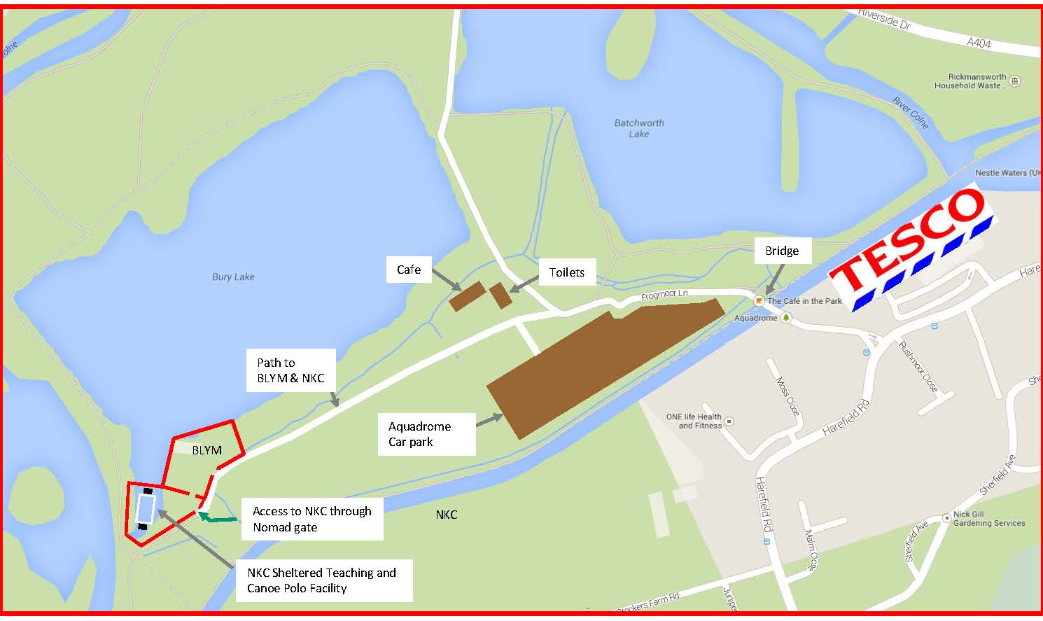
Participants are asked not to attend if they have displayed coronavirus symptoms (raised temperature, persistent cough, loss of taste or smell) or been in close contact with someone who has displayed symptoms within the last 14 days.
Private outdoor changing facilities are available should you wish to use them though many people find it easier to arrive in the clothes they intend to paddle in, hot showers are available should you wish to wash before you leave at the end of your session.
What to wear
- a pair of water shoes or non-bulky trainers (that may get wet)
- a T-shirt
- a pair of shorts/leggings
- a waterproof top (cagoule or similar) for if it’s windy
- a lightweight fleece (optional)
- a wetsuit (optional)
- we will provide a buoyancy aid which must be worn whenever you are afloat

What else you will need to bring
- a towel
- a full change of clothes, this is a water based activity and you are likely to get wet
- a bottle of water
- Sun hat (if sunny weather is forecast)
- Sun cream (if sunny weather is forecast)
- A packed lunch and a cold drink – hot drinks will be supplied should you need one.

Whilst most legal restrictions to control COVID-19 have now been lifted, once on site your activity leader will give you a COVID briefing identifying any control measures that are still being observed on the site.
If you need to leave early or are going to arrive late, please ensure that you let us know well before the session as we may need to make alternative arrangements to accommodate you.

Should you have any questions, please do not hesitate to contact me or take a look at the Useful Information Page on our website: Canoesportstrust.org.uk

Kind Regards,

Paul Childerhouse
CST Senior Coach
E: courses@canoesportstrust.org.uk

